

Minutes of Meeting
Eionet Thematic Group on Digital Capabilities and AI – In-person meeting at EEA, Copenhagen
Meeting Title: | Eionet Thematic Group on Digital Capabilities and AI - meeting | Meeting Date/  Time: | 29.06.2026 – 30.06.2026 /  13:00 to 13:00
Meeting Type: | Thematic Group on Digital Capabilities and AI | Meeting Location: | In-person workshop
Meeting Coordinator: | Sune Djurhuus | Issue Date: | 22.10.2026

Opening of the Meeting
Meeting Hosts:
Sune Djurhuus, EEA
Ana Dukic,
Annalisa Minelli,
Martin Tychina,
Gregor Rosenauer, UBA Vienna
The meeting marked the third of the Eionet Thematic Group on Digital Capabilities and AI and was held as an in-person at the EEA in Copenhagen covering two half days September 29-30, 2026.
Meeting purpose
Following the survey outcomes and the group work of 17 June 2026, this is the meeting at which the group converts its priority questions into clear mission with designed targets and way to achieve them.
Expected outputs
- Main aim (addressing gains and expectations) and list of targets to be achieved by 31.12.2028
- Portfolio of outcomes and related actions fulfilling the targets across defined 4 topics
- Defined roadmap with milestones addressing priorities
- Light weight working model (meetings, assignments, reporting, communication, etc.)
Meeting documents:
- Agenda
- EEA AI EIONET Perspective
- 4 x 5-minute pitches of the topics
- Use Cases
- Minutes of Meeting

Check in
Purpose: participants created a map locating themselves (N-S-E-W) and gave a short presentation/pitch of who they are and express one main expectation and one proposal /capacity she/he is willing to offer to the TG

AI at the EEA and outlook

Presentation: 2026-09-29_EEA AI Eionet perspective.pdf
Presented by:
Karl Hamilton, Head of Digital Department, EEA
Irantzu Sadaba, Head of Unit, Digital Transformation and Technology Services
4 x 5-minute pitches of the topics
4 x 5-minute pitches of the topics (facilitated by)

- Strategy, Governance and Organisation (Annalisa)
- People, Skills and Ways of Working (Simon)
- Data, Technologies and Infrastructure (Martin)
- AI Applications and Value Creation (Gregor)

Where are we:
- Trends
- Proposed targets to be achieved
- Potential outcomes and actions

Presentation of the topics: TG_Digital_Capabilities_AI_ 4 x 5-minute pitches of the topics.pdf

Parallel sessions and roadmap results
The 4 topics were discussed in parallel sessions on September 29 and then a roadmap discussion and how we take the work forward was discussed and concluded on September 30. In the following sections, the combined information coming from these sessions is presented together for each topic.
The overall structure for each session was to share ideas and discuss:
- Targets
- Outcomes
- Actions
- Who and how will we take the work forward
Hot topics (Hot topics for further investigation) on the roadmap is listed under the Targets, Outcomes, and Actions.

T1 Strategy, Governance and Organisation

The session was led by Annalisa Minelli with the help from Martin Tuchyna.
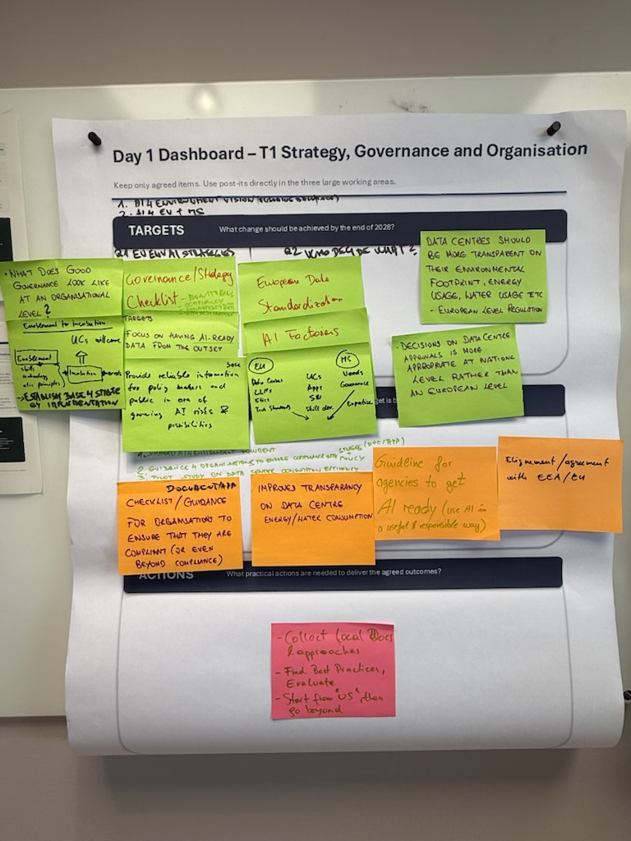
The raw extracted information extracted from the post can be found here:
TARGETS
- Define organisational AI governance and a checklist for monitoring, compliance, EEA alignment and best practice.
- Support needs-led incubation with skills, technology and ethics. Build AI-ready data from the outset.
Provide reliable information for policymakers and the public amid AI risks and opportunities.
EU AND MEMBER STATE ROLES
EU: European data, standardisation, AI factories, data centres, LLMs, ethics and technical standards.
Member States: needs, governance and expertise to inform use cases, apps, possible software and skills development.
Propose EU rules for transparent data-centre environmental, energy and water footprints. Keep approvals at national level.
Hot topics for further investigation:
- Distinguish what should be managed by EU and MS
  - EU: Dataflows, ethics (strategy), technical standards
  - MS: needs, governance, data centres
- AI for environment vision (balance opportunies/risks, governance/strategy checklist, assess environmental footprint of data centers
OUTCOMES
- Shared AI for Environment empowerment
- Guidance for organisations to ensure compliance with Strategy + policy (POC/ATP).
- Pilot study on data center consumption efficiency
- Documentation, checklists and guidance for For orgnisations to ensure that they are compliant (or even beyond-compliance).
- Improved transparency of data-centre energy and water consumption.
- Guidelines supporting agencies in becoming AI-ready and using AI in a useful and responsible way.
- Alignment/Agreement with EEA/EU.
Hot topics for further investigation:
- Shared AI for Environment document assessing the state of the art of policies at EU and MS level, funding resources, synergies among EU-EEA (DG CONNECT)
- Checklist/Guidance for organisations to ensure policy (strategies) compliance (and virtuous behaviours), LIST/APP.
- Pilot study on a data center environmental impact (energy usage, water usage) by means of existing monitoring tool. Impacts/ risks
ACTIONS
- Collect local Docs and approaches.
- Identify and evaluate best practices.
- Start with internal experience and then broaden the exercise beyond.
Hot topics for further investigation:
- Collect local (MS) documents and approaches (review work)
- Create a repository of best practices and evaluate them
- Collect “local needs” and understand what’s missing/integrate them
THE GROUP AND PARTICIPATION/CONTRIBUTIONS
Participant | Contribution
Annalisa Minelli (IT) | Start doing research on European (MS) strategies/policies
Martin Tuchyna (SK) | Contribute to summary of event. Propose input to roadmap. Initiate the outcomes template. Contribute to topics coordination
Juliana Bogdeviciene (LT) | Talk with colleagues for more ideas on this topic
Stephen Fennel (IE) | Identify the roles/levels in the organisation relevant to the governance/oversight of AI and stat to collect info from Member States
Sune Djurhuus (EEA) | Provide support to Group and share knowledge
Stephan Li (AT)
Davide Chen (IT) | Share experiences in other networks and coalitions on AI
Alberto Marin Guillen (ES)
Erkki Mervaala (FI) | Identify information needs for AI Env. Impact
Simon Becker (DE)

T2: People, Skills and Ways of Working
The session was led by Simon Becker with the help from Sune Djurhuus
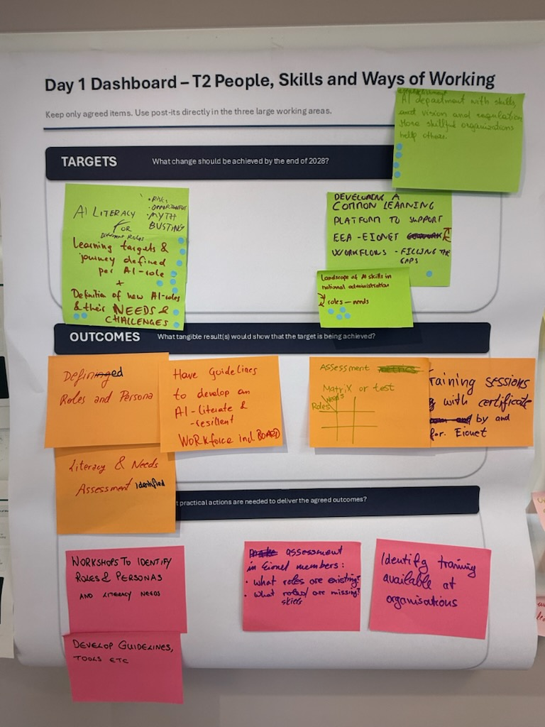
The sessions focused on identifying Targets, Outcomes and Actions but also to flag offers and needs among the participants.
TARGETS
- Establish AI literacy for different roles.
- Risks, Opportunities, Myth Busting
- Learning targets and journey defined per AI role +
- Definition of new AI roles, including their needs and challenges.
- Develop a common learning platform supporting EEA-Eionet workflows and filling identified gaps.
- Map the landscape of AI skills, roles and needs in national administrations.
- Establishment of AI department with skills, vision and regulation. More skill full organisations support others
Hot topics for further investigation:
- Having a clear picture of roles and needed skills in an age of AI
- Having a common learning platform that meets demands of Eionet Members and utilises experience and knowledge
OUTCOMES
- Defined roles and personas.
- Literacy and need assessment identified
- Have guidelines to develop and AI literate and resilient work force including board
- An assessment matrix or test linking roles and needs.
- Training sessions with certification by and for Eionet.
Hot topics for further investigation:
- Training sessions
- Guideline to develop an AI literacy resilient workforce
- Assessment of literacy and needs
ACTIONS
- Conduct workshops to identify roles, personas and literacy needs.
- Develop supporting guidelines and tools etc.
- Assess existing and missing roles and skills across Eionet members.
- Identify training already available within organisations.
Hot topics for further investigation:
- Collect existing capability building concepts, role models etc from TG
- Workshop to identify roles and literacy
- Survey
- Develop Guidelines, tools etc.
- AI tools evaluation grid, also considering their fairness to use for workers
- Ways of learning
WHAT CAN YOU OFFER/WHAT IS YOUR NEED?
OFFERS
- Examples from my organsation on processes and matriels
- My experience
- Experiences from different regional administrations
- Experience in AI training
- Roles fro individuals, comittees, sub boards (KT)
- Local LLM for research
- Connect Eionet to EEA AI learning
- Use Cases
- Be more like Business company not like government
- Not experienced in this
NEED
- Local LLM Example
- Sharing of best practices
- Learning path for specific roles
- To hear what others are doing
- People/Department financing
- Upskilling approach and needs assessment
- Examples on Management Training
- How to reach a national standard
Participant | Contribution
Simon Becker (DE) | Share UBA concept for AI. Training + Data related roles
Annalisa Minelli (IT)
Sune Djurhuus (EEA) | Provide support to Group and share knowledge
Stephan Li (AT)
Davide Chen (IT) | Share experiences in other networks and coalitions on AI
Alberto Marin Guillen (ES)
Matej Cunder | Identify information needs for AI Env. Impact
Erkki Mervaala (FI) | Identifying needs and roles in my organisation/network
THE GROUP AND PARTICIPATION/CONTRIBUTION

T3 Data, Technologies and Infrastructure
The session was led by Martin Tuchyna with the help from Ana Dukic.
Additional meeting notes: Data, technologies and infrastructure - Notes.docx

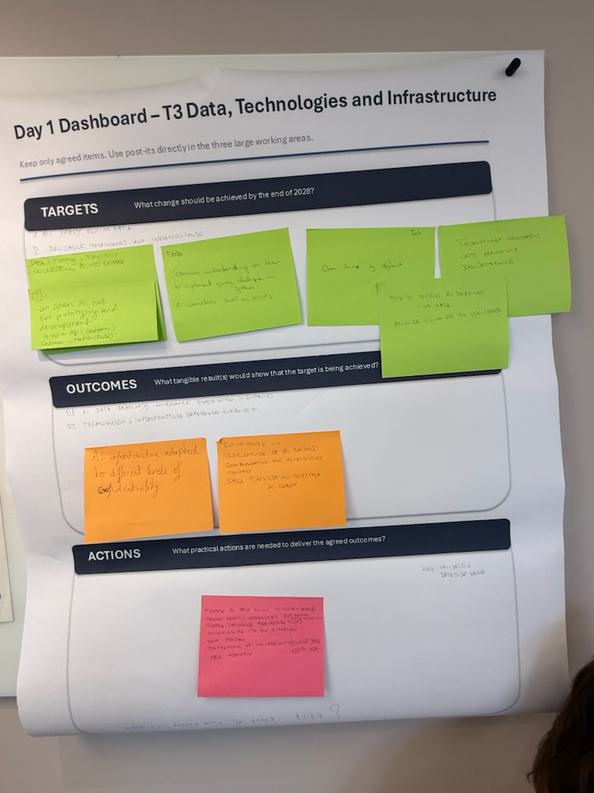
TARGETS
- Data + Platfom + Technology
- Collecting as is + to be data
- Establish an open AI hub for prototyping and development. HW + API – Platform, Common infrastructures
- Establish a common understanding of how to implement strategies and policies for data requirements for AI. AI connections such as MCPs
- Open source by default (Tech)
- Technology validation cost efficiency benchmarking.
- How to improve AI readiness of data, ensure linkage to use cases
Hot topics for further investigation:
- AI ready Environment data
- Reusable technology and infrastructure
OUTCOMES
- AI data readiness governance framework (+guidance)
- Technology and Infrastructure reference overview
Hot topics for further investigation:
- AI infrastructure adapted to different levels of confidentiality.
- Benchmark - > Reference of AI platform recommendation for architecture standard
- Data prioritisation roadmap and AI Ready
ACTIONS
- Prepare AI data Reuse criteria + sample.
- Develop agentic capabilities – MCP protocol
- Prepare reference architecture pilots
- Collect as is – to be situation
- Best Practise
- Propagation of Souvreignity (ensure data access)
Hot topics for further investigation:
1)
- AI readiness criteria
- Pivot AI Data Samples
- Testing criteria (readiness) on pilot data
2)
- Collect examples of relevant platforms, architectures, standards
- Identify common technical needs, reusable approaches and gaps
- Prepare and validate the reference overview
THE GROUP AND PARTICIPATION/CONTRIBUTIONS
Participant | Contribution
Martin Tuchyna (SK) | Share UBA concept for AI. Training + Data related roles
Annalisa Minelli (IT) | Start studying what IA-readiness implies for key institutions (ISPRA) data
Sune Djurhuus (EEA) | Provide support to Group and share knowledge
Cecilia Zetterstrom (SE) | Throw out a question to my national AI network if they have examples/templates of how they work with getting data AI-Ready
Taavi Pipar (EE) | Write down Estonian requirements
Marco Kronenberg (CH)
Alberto Marin Guillen (ES) | Collect legislation about AI with affect to data
Miroslav Kukuc (CZ) | First draft of data standard
Luis Baltazar (PT) | Gathering European data models
Bino Miaheu (BE)
Karim Tayakout (FR) | Test data processing automation with AI

T4 AI Applications and Value Creation
The session was led by Gregor Rosenauer with the help from Ana Dukic.
Additional meeting notes: AI Applications and Value Creation - Notes.docx
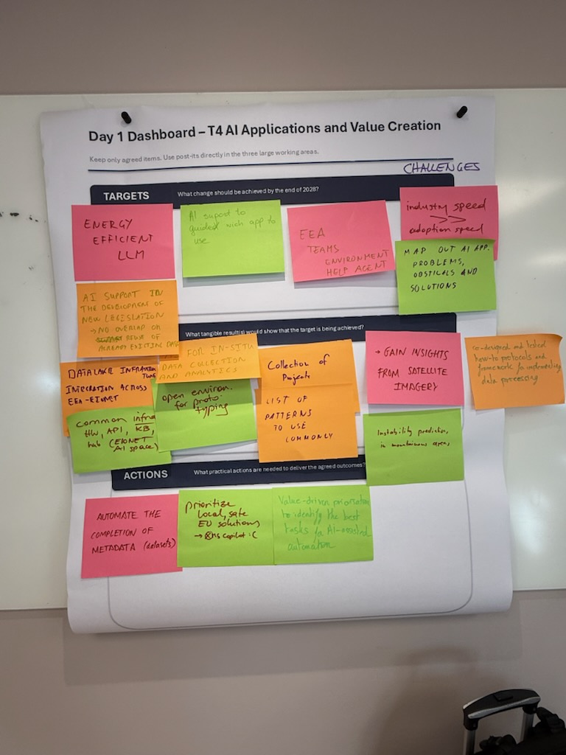
The session was built up around identifying use cases and assess impact (value impact/cost – risk). The use cases send by participants in advance of the meeting can be found here: AI Use Cases
TARGETS
- Energy-efficient LLMs.
- AI support to guide which app to use.
- EEA teams environment help agent
- Industry speed >> adoption speed
- Map out AI app. Problems, obstacles and solutions
- AI Support in the development of new legislation -> no overlap or reuse of already existing data
Hot topics for further investigation:
- Energy efficient AI
- AI Data, knowledge and solution sharing
OUTCOMES
- Data Lake infrastructure integration across EEA-Eionet.
- Common infrastructure HW, API, KB, Hub (Eionet AI Space)
- AI for In-Situ data collections and analytics.
- An open environment for prototyping
- Collection of projects
- List of patterns patterns to use commonly.
- Insights derived from satellite imagery.
- Instability prediction on mountainous area
- Co-designed/tested how-to protocols and frameworks for data processing.
Hot topics for further investigation:
- AI semantic layer (MCP Server, domain, AGENTS and skills, training data)
- Provide a common AI Infrastructure (HW, services, data)
- AI solutions portfolio/gallery (apps, work, use case learnings, patterns)
- AI assisted consolidation of regulation to find gaps, overlap, contradictions
- AI lense on data (insights, QA, Gaps, overlap, instability, reproducibility
ACTIONS
- Automate completion of dataset metadata.
- Prioritise local, safe EU solutions. (not MS Co-pilot)
- Use value-driven prioritisation to identify the most suitable tasks for AI assistance or automation.
- Setting up a small template for a use case catalog.
Hot topics for further investigation:
- AI identification of high value/impact use cases not only for research but also for operational/workflow reporting
- Data sovereignty, FOSS open source, local flavour, EU wide hosted solution
- Data automation (sanitize metadata, dacilitate + reuse existing data, harmonise and mobilise, find gaps, overlaps, map and consolidate contradictions, AI ready data

VALUE / IMPACT VS. COST/RISK EVALUATION
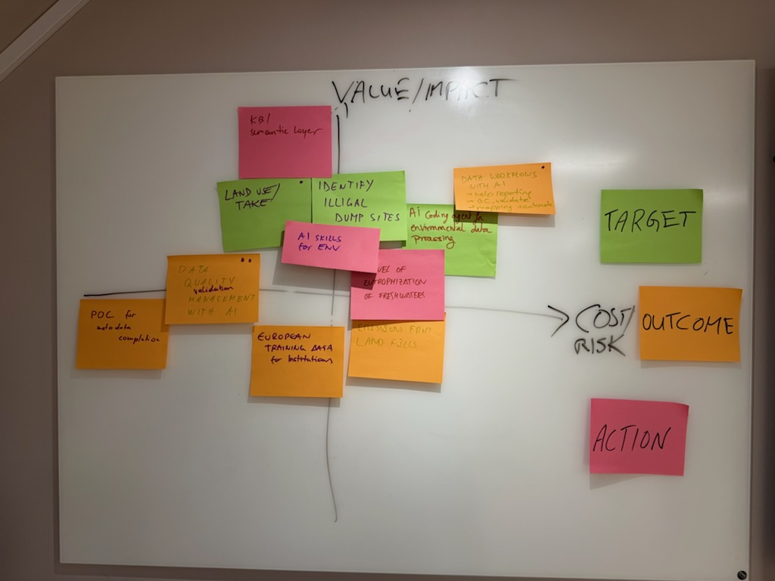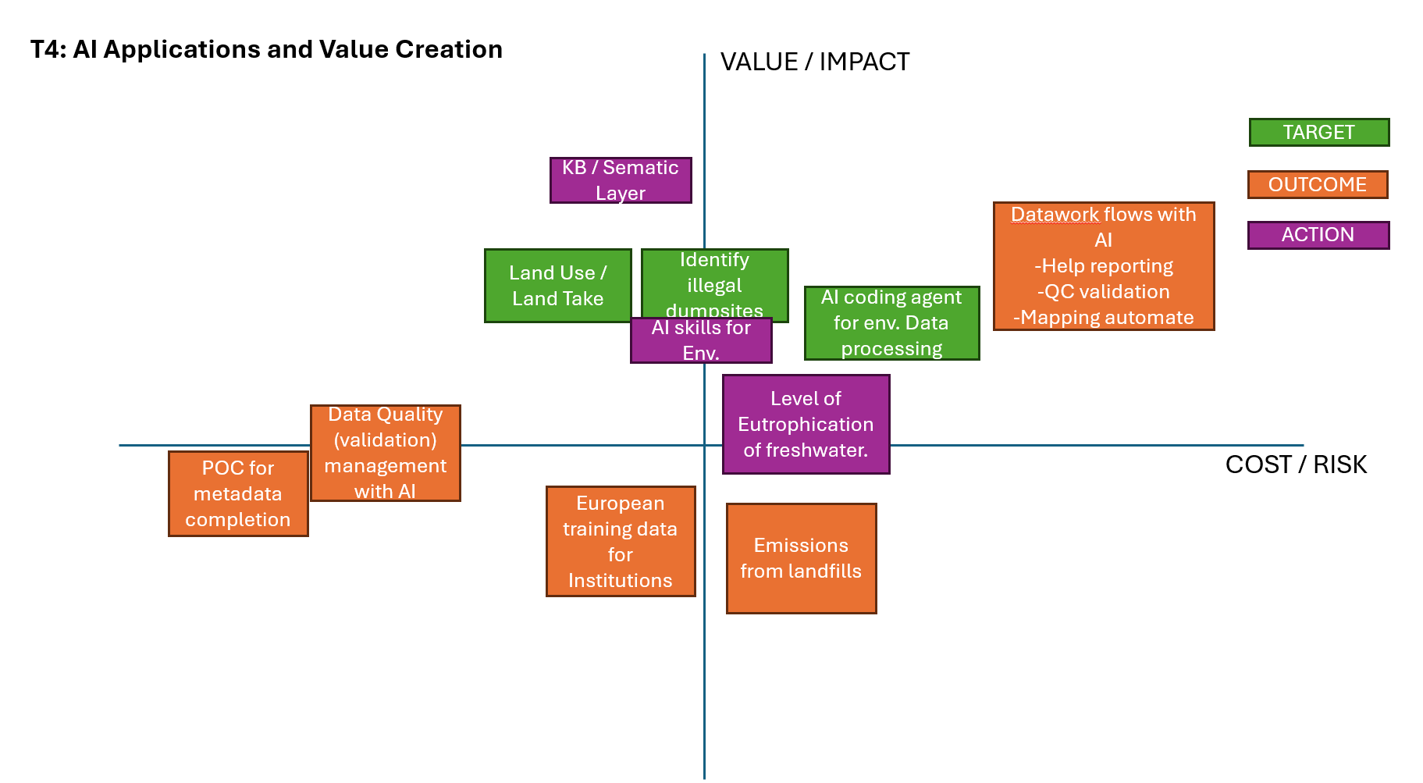

ROADMAP SESSION FOR PRIORITISATION
Results are listed as Hot topics under each topic. Here are the original posters:
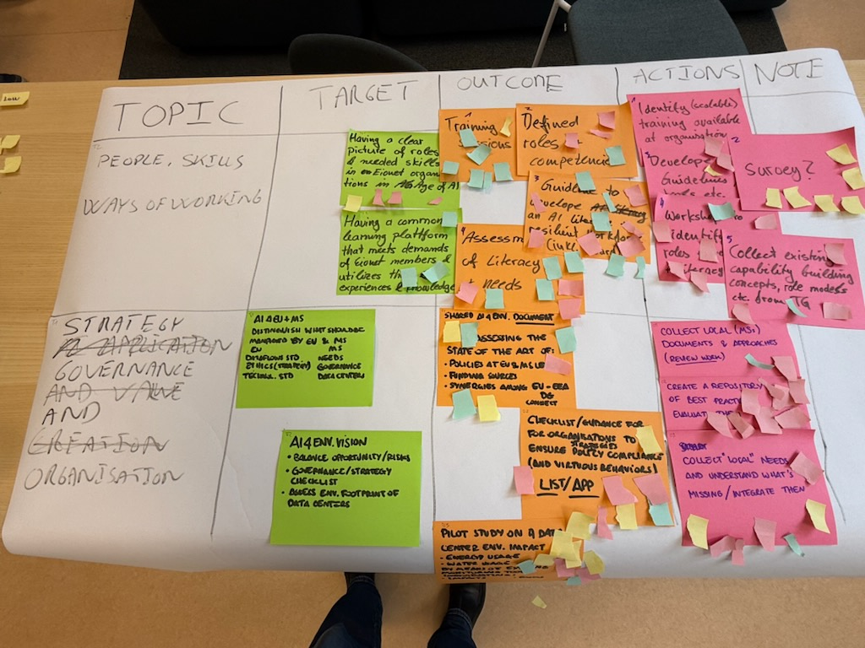

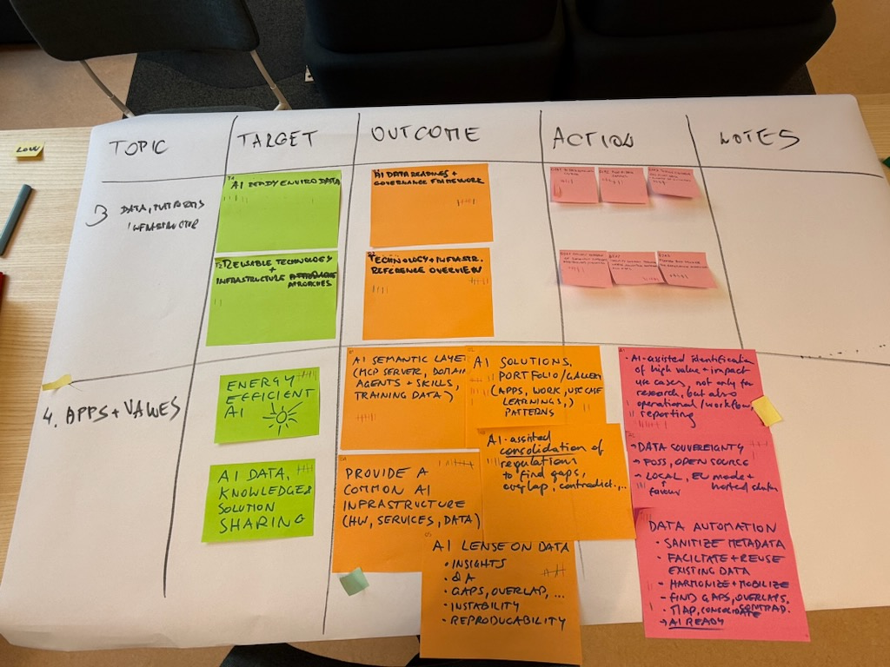

CHECK OUT
Check out question:
How are you leaving this meeting? – one word
